Task 5: JavaFX
  - To Create Different Layouts with JavaFX animation.
  - To Design a web application with JavaFX event handling.

5.1 Create simple calculator using JavaFx by using VBox Layout
Program:
import javafx.application.Application;
import javafx.beans.binding.Bindings;
import javafx.beans.property.*;
import javafx.geometry.Pos;
import javafx.scene.Scene;
import javafx.scene.control.*;
import javafx.scene.input.KeyEvent;
import javafx.scene.layout.*;
import javafx.stage.*;

import java.util.*;

// a simple JavaFX calculator.
public class Main extends Application {
private static final String[][] template = {
{"7", "8", "9", "/"},
{"4", "5", "6", "*"},
{"1", "2", "3", "-"},
{"0", "c", "=", "+"}
};

private final Map<String, Button> accelerators = new HashMap<>();

private final DoubleProperty stackValue = new SimpleDoubleProperty();
private final DoubleProperty value = new SimpleDoubleProperty();

private enum Op {NOOP, ADD, SUBTRACT, MULTIPLY, DIVIDE}

private Op curOp = Op.NOOP;
private Op stackOp = Op.NOOP;

public static void main(String[] args) {
launch(args);
}

@Override
public void start(Stage stage) {
final TextField screen = createScreen();
final TilePane buttons = createButtons();

stage.setTitle("Calc");
stage.initStyle(StageStyle.UTILITY);
stage.setResizable(false);
stage.setScene(new Scene(createLayout(screen, buttons)));
stage.show();
}

private VBox createLayout(TextField screen, TilePane buttons) {
final VBox layout = new VBox(20);
layout.setAlignment(Pos.CENTER);
layout.setStyle("-fx-background-color: chocolate; -fx-padding: 20; -fx-font-size: 20;");
layout.getChildren().setAll(screen, buttons);
handleAccelerators(layout);
screen.prefWidthProperty().bind(buttons.widthProperty());
return layout;
}

private void handleAccelerators(VBox layout) {
layout.addEventFilter(KeyEvent.KEY_PRESSED, keyEvent -> {
Button activated = accelerators.get(keyEvent.getText());
if (activated != null) {
activated.fire();
}
});
}

private TextField createScreen() {
final TextField screen = new TextField();
screen.setStyle("-fx-background-color: aquamarine;");
screen.setAlignment(Pos.CENTER_RIGHT);
screen.setEditable(false);
screen.textProperty().bind(Bindings.format("%.0f", value));
return screen;
}

private TilePane createButtons() {
TilePane buttons = new TilePane();
buttons.setVgap(7);
buttons.setHgap(7);
buttons.setPrefColumns(template[0].length);
for (String[] r : template) {
for (String s : r) {
buttons.getChildren().add(createButton(s));
}
}
return buttons;
}

private Button createButton(final String s) {
Button button = makeStandardButton(s);

if (s.matches("[0-9]")) {
makeNumericButton(s, button);
} else {
final ObjectProperty<Op> triggerOp = determineOperand(s);
if (triggerOp.get() != Op.NOOP) {
makeOperandButton(button, triggerOp);
} else if ("c".equals(s)) {
makeClearButton(button);
} else if ("=".equals(s)) {
makeEqualsButton(button);
}
}

return button;
}

private ObjectProperty<Op> determineOperand(String s) {
final ObjectProperty<Op> triggerOp = new SimpleObjectProperty<>(Op.NOOP);
switch (s) {
case "+" -> triggerOp.set(Op.ADD);
case "-" -> triggerOp.set(Op.SUBTRACT);
case "*" -> triggerOp.set(Op.MULTIPLY);
case "/" -> triggerOp.set(Op.DIVIDE);
}
return triggerOp;
}

private void makeOperandButton(Button button, final ObjectProperty<Op> triggerOp) {
button.setStyle("-fx-base: lightgray;");
button.setOnAction(actionEvent -> curOp = triggerOp.get());
}

private Button makeStandardButton(String s) {
Button button = new Button(s);
button.setStyle("-fx-base: beige;");
accelerators.put(s, button);
button.setMaxSize(Double.MAX_VALUE, Double.MAX_VALUE);
return button;
}

private void makeNumericButton(final String s, Button button) {
button.setOnAction(actionEvent -> {
if (curOp == Op.NOOP) {
value.set(value.get() * 10 + Integer.parseInt(s));
} else {
stackValue.set(value.get());
value.set(Integer.parseInt(s));
stackOp = curOp;
curOp = Op.NOOP;
}
});
}

private void makeClearButton(Button button) {
button.setStyle("-fx-base: mistyrose;");
button.setOnAction(actionEvent -> value.set(0));
}

private void makeEqualsButton(Button button) {
button.setStyle("-fx-base: ghostwhite;");
button.setOnAction(actionEvent -> {
switch (stackOp) {
case ADD -> value.set(stackValue.get() + value.get());
case SUBTRACT -> value.set(stackValue.get() - value.get());
case MULTIPLY -> value.set(stackValue.get() * value.get());
case DIVIDE -> value.set(stackValue.get() / value.get());
}
});
}
}
Output:
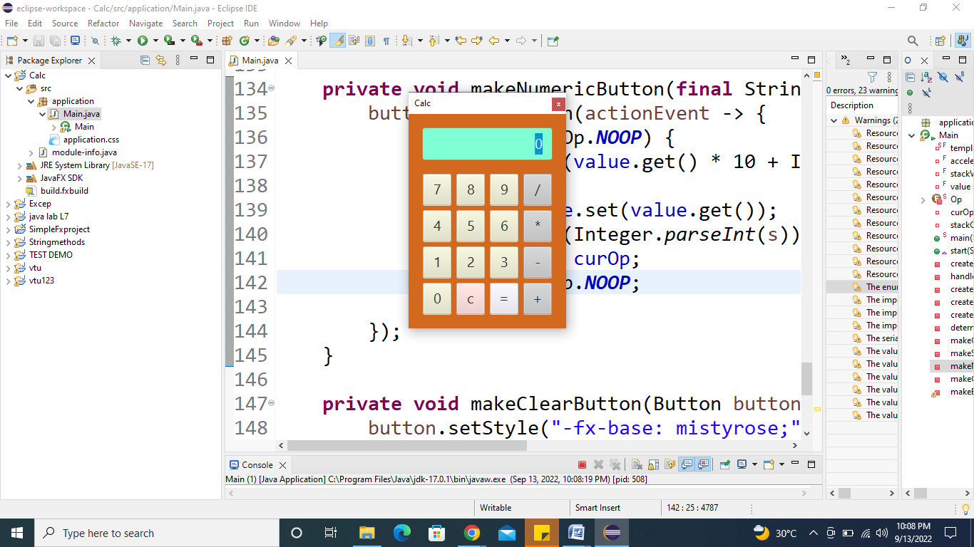

5.2 Create event handler with two different buttons. The event source is discriminated in the handle() method. The circle starts translating in the positive X direction when the Play button is clicked while It gets paused when the Pause button is clicked.
Program:
import javafx.animation.TranslateTransition;
import javafx.application.Application;
import javafx.event.EventHandler;
import javafx.scene.Group;
import javafx.scene.Scene;
import javafx.scene.control.Button;
import javafx.scene.input.MouseEvent;
import javafx.scene.paint.Color;
import javafx.scene.shape.Circle;
import javafx.stage.Stage;
import javafx.util.Duration;
public class Main extends Application{
@Override
public void start(Stage primaryStage) throws Exception {
// TODO Auto-generated method stub
//Creating Circle and setting the color and stroke in the circle
Circle c = new Circle(100,100,50);
c.setFill(Color.GREEN);
c.setStroke(Color.BLACK);

//creating play button and setting coordinates for the button
Button btn = new Button("Play");
btn.setTranslateX(125);
btn.setTranslateY(200);

// creating pause button and setting coordinate for the pause button
Button btn1 = new Button("Pause");
btn1.setTranslateX(175);
btn1.setTranslateY(200);

//Instantiating TranslateTransition class to create the animation
TranslateTransition trans = new TranslateTransition();

//setting attributes for the TranslateTransition
trans.setAutoReverse(true);
trans.setByX(200);
trans.setCycleCount(100);
trans.setDuration(Duration.millis(500));
trans.setNode(c);

//Creating EventHandler
EventHandler<MouseEvent> handler = new EventHandler<MouseEvent>() {

@Override
public void handle(MouseEvent event) {
// TODO Auto-generated method stub

if(event.getSource()==btn)
{
trans.play(); //animation will be played when the play button is clicked
}
if(event.getSource()==btn1)
{
trans.pause(); //animation will be paused when the pause button is clicked
}
event.consume();
}

};

//Adding Handler for the play and pause button
btn.setOnMouseClicked(handler);
btn1.setOnMouseClicked(handler);

//Creating Group and scene
Group root = new Group();
root.getChildren().addAll(c,btn,btn1);
Scene scene = new Scene(root,420,300,Color.WHEAT);
primaryStage.setScene(scene);
primaryStage.setTitle("EventHandler example");
primaryStage.show();
}
public static void main(String[] args) {
launch(args);
}
}
Output:
